# PureEthernetStructure_Pac

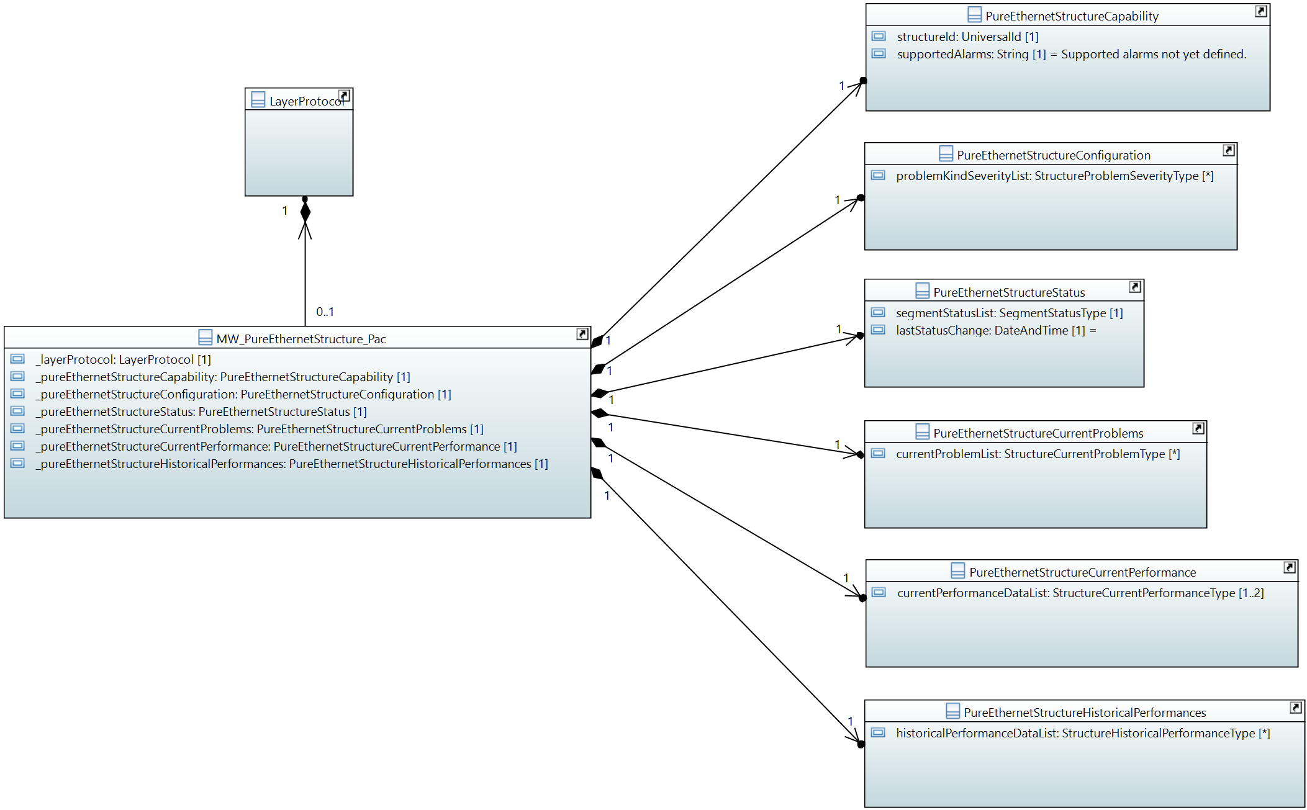

## MW_PureEthernetStructure_Pac

Qualified Name: MicrowaveModel::ObjectClasses::PureEthernetStructure::MW_PureEthernetStructure_Pac

The pureEthernetStructure_Pac and its attached classes MUST be provided on management interfaces of microwave devices, which are transporting Ethernet traffic only.

Applied stereotypes:

* OpenModelClass
* objectCreationNotification: YES
* objectDeletionNotification: YES
* support: CONDITIONAL_MANDATORY
* condition: Feature 'pure-ethernet' is mandatory for device types transporting pure Ethernet.

Table 10: Attributes for MW_PureEthernetStructure_Pac

| **Attribute Name** | **Type DefaultValue** | **Multiplicity** | **Access** | **Stereotypes** | **Description** |
| --- | --- | --- | --- | --- | --- |
| _layerProtocol | LayerProtocol  ./. | 1 | RW | OpenModelAttribute   * partOfObjectKey: 1 * AVC: NO * isInvariant: false * valueRange: no range constraint * bitLength: NA * unit: no unit defined * support: MANDATORY | CoreModel-CoreNetworkModule-ObjectClasses:NetworkElement/_ltpRefList/_lpList/uuid |
| _pureEthernetStructureCapability | PureEthernetStructureCapability  ./. | 1 | R | OpenModelAttribute   * partOfObjectKey: 0 * AVC: NO * isInvariant: false * valueRange: no range constraint * bitLength: NA * unit: no unit defined * support: MANDATORY | See referenced class |
| _pureEthernetStructureConfiguration | PureEthernetStructureConfiguration  ./. | 1 | RW | OpenModelAttribute   * partOfObjectKey: 0 * AVC: NO * isInvariant: false * valueRange: no range constraint * bitLength: NA * unit: no unit defined * support: MANDATORY | See referenced class |
| _pureEthernetStructureStatus | PureEthernetStructureStatus  ./. | 1 | R | OpenModelAttribute   * partOfObjectKey: 0 * AVC: NO * isInvariant: false * valueRange: no range constraint * bitLength: NA * unit: no unit defined * support: MANDATORY | See referenced class |
| _pureEthernetStructureCurrentProblems | PureEthernetStructureCurrentProblems  ./. | 1 | R | OpenModelAttribute   * partOfObjectKey: 0 * AVC: NO * isInvariant: false * valueRange: no range constraint * bitLength: NA * unit: no unit defined * support: MANDATORY | See referenced class |
| _pureEthernetStructureCurrentPerformance | PureEthernetStructureCurrentPerformance  ./. | 1 | R | OpenModelAttribute   * partOfObjectKey: 0 * AVC: NO * isInvariant: false * valueRange: no range constraint * bitLength: NA * unit: no unit defined * support: MANDATORY | See referenced class |
| _pureEthernetStructureHistoricalPerformances | PureEthernetStructureHistoricalPerformances  ./. | 1 | R | OpenModelAttribute   * partOfObjectKey: 0 * AVC: NO * isInvariant: false * valueRange: no range constraint * bitLength: NA * unit: no unit defined * support: MANDATORY | See referenced class |

## PureEthernetStructureCapability

Qualified Name: MicrowaveModel::ObjectClasses::PureEthernetStructure::PureEthernetStructureCapability

Describes the logical structuring of the physical capacity provided by a pure Ethernet microwave device. Segmentation is not available. No fixed segment size. No TDM transport.

Applied stereotypes:

* OpenModelClass
* objectCreationNotification: NO
* objectDeletionNotification: NO
* support: MANDATORY

Table 11: Attributes for PureEthernetStructureCapability

| **Attribute Name** | **Type DefaultValue** | **Multiplicity** | **Access** | **Stereotypes** | **Description** |
| --- | --- | --- | --- | --- | --- |
| structureId | UniversalId  ./. | 1 | R | OpenModelAttribute   * partOfObjectKey: 1 * AVC: NO * isInvariant: true * valueRange: no range constraint * bitLength: NA * unit: no unit defined * support: MANDATORY | Identifies the Structure for bundling and container. |
| supportedAlarms | String  Supported alarms not yet defined. | 1 | R | OpenModelAttribute   * partOfObjectKey: 0 * AVC: NO * isInvariant: true * valueRange: no range constraint * bitLength: NA * unit: no unit defined * support: MANDATORY | Available alarms to be listed. Mandatory:non. Names are to be separated by commas. Further alarms might be added by the device. |

## PureEthernetStructureConfiguration

Qualified Name: MicrowaveModel::ObjectClasses::PureEthernetStructure::PureEthernetStructureConfiguration

Applied stereotypes:

* OpenModelClass
* objectCreationNotification: NO
* objectDeletionNotification: NO
* support: MANDATORY

Table 12: Attributes for PureEthernetStructureConfiguration

| **Attribute Name** | **Type DefaultValue** | **Multiplicity** | **Access** | **Stereotypes** | **Description** |
| --- | --- | --- | --- | --- | --- |
| problemKindSeverityList | StructureProblemSeverityType  ./. | 0..* | RW | OpenModelAttribute   * partOfObjectKey: 0 * AVC: YES * isInvariant: false * valueRange: no range constraint * bitLength: NA * unit: no unit defined * support: MANDATORY | Severity of the type of problem to be configured. |

## PureEthernetStructureStatus

Qualified Name: MicrowaveModel::ObjectClasses::PureEthernetStructure::PureEthernetStructureStatus

Applied stereotypes:

* OpenModelClass
* objectCreationNotification: NO
* objectDeletionNotification: NO
* support: MANDATORY

Table 13: Attributes for PureEthernetStructureStatus

| **Attribute Name** | **Type DefaultValue** | **Multiplicity** | **Access** | **Stereotypes** | **Description** |
| --- | --- | --- | --- | --- | --- |
| segmentStatusList | SegmentStatusType  ./. | 1 | R | OpenModelAttribute   * partOfObjectKey: 0 * AVC: YES * isInvariant: false * valueRange: no range constraint * bitLength: NA * unit: no unit defined * support: MANDATORY | Status of the Ethernet transport segment. Always just one segment. |
| lastStatusChange | DateAndTime  20101120140000.0Z+1 | 1 | R | OpenModelAttribute   * partOfObjectKey: 0 * AVC: NO * isInvariant: false * valueRange: no range constraint * bitLength: NA * unit: no unit defined * support: MANDATORY | Time and date of the last update of the status information. _format:yyyyMMddhhmmss.s[Z|{+|-}HHMm]; yyyy='0000'..'9999' year; MM='01'..'12' month; dd='01'..'31' day; hh='00'..'23' hour; mm='00'..'59' minute; ss='00'..'59' second; s='.0'..'.9'tenth of second (set to '.0' if EMS or NE cannot support this granularity); Z='Z' indicates UTC (rather than local time); {+|-}='+' or '-' delta from UTC; HH='00'..'23' time zone difference in hours; Mm='00'..'59' time zone difference in minutes. |

## PureEthernetStructureCurrentProblems

Qualified Name: MicrowaveModel::ObjectClasses::PureEthernetStructure::PureEthernetStructureCurrentProblems

Applied stereotypes:

* OpenModelClass
* objectCreationNotification: NO
* objectDeletionNotification: NO
* support: MANDATORY

Table 14: Attributes for PureEthernetStructureCurrentProblems

| **Attribute Name** | **Type DefaultValue** | **Multiplicity** | **Access** | **Stereotypes** | **Description** |
| --- | --- | --- | --- | --- | --- |
| currentProblemList | StructureCurrentProblemType  ./. | 0..* | R | OpenModelAttribute   * partOfObjectKey: 0 * AVC: NO * isInvariant: false * valueRange: no range constraint * bitLength: NA * unit: no unit defined * support: MANDATORY |  |

## PureEthernetStructureCurrentPerformance

Qualified Name: MicrowaveModel::ObjectClasses::PureEthernetStructure::PureEthernetStructureCurrentPerformance

Aggregated performance information of the structure of an pure Ethernet microwave at a particular moment.

Applied stereotypes:

* OpenModelClass
* objectCreationNotification: NO
* objectDeletionNotification: NO
* support: MANDATORY

Table 15: Attributes for PureEthernetStructureCurrentPerformance

| **Attribute Name** | **Type DefaultValue** | **Multiplicity** | **Access** | **Stereotypes** | **Description** |
| --- | --- | --- | --- | --- | --- |
| currentPerformanceDataList | StructureCurrentPerformanceType  ./. | 1..2 | R | OpenModelAttribute   * partOfObjectKey: 0 * AVC: NO * isInvariant: false * valueRange: no range constraint * bitLength: NA * unit: no unit defined * support: MANDATORY | At least values of the counters, which are reset every 15 minutes, are to be provided. If available, the current values of the counters, which are reset every 24 hour, can be provided, too. |

## PureEthernetStructureHistoricalPerformances

Qualified Name: MicrowaveModel::ObjectClasses::PureEthernetStructure::PureEthernetStructureHistoricalPerformances

Aggregated performance information of the structure of an pure Ethernet microwave for a pre-defined measurement interval.

Applied stereotypes:

* OpenModelClass
* objectCreationNotification: NO
* objectDeletionNotification: NO
* support: MANDATORY

Table 16: Attributes for PureEthernetStructureHistoricalPerformances

| **Attribute Name** | **Type DefaultValue** | **Multiplicity** | **Access** | **Stereotypes** | **Description** |
| --- | --- | --- | --- | --- | --- |
| historicalPerformanceDataList | StructureHistoricalPerformanceType  ./. | 0..* | R | OpenModelAttribute   * partOfObjectKey: 0 * AVC: NO * isInvariant: false * valueRange: no range constraint * bitLength: NA * unit: no unit defined * support: MANDATORY |  |

# Data Types

## StructureProblemSeverityType

Qualified Name: MicrowaveModel::TypeDefinitions::StructureProblemSeverityType

Table 61: Attributes for StructureProblemSeverityType

| **Attribute Name** | **Type DefaultValue** | **Multiplicity** | **Access** | **Stereotypes** | **Description** |
| --- | --- | --- | --- | --- | --- |
| problemKindName | String  Problem kind name not defined. | 1 | RW | OpenModelAttribute   * partOfObjectKey: 1 * AVC: NA * isInvariant: true * valueRange: no range constraint * bitLength: NA * unit: no unit defined * support: MANDATORY | Name of the alarm according to Structure::StructureCapability::supportedAlarms |
| problemKindSeverity | SeverityType  WARNING | 1 | RW | OpenModelAttribute   * partOfObjectKey: 0 * AVC: YES * isInvariant: false * valueRange: no range constraint * bitLength: NA * unit: no unit defined * support: MANDATORY | Severity of this type of alarm. |

## StructureCurrentProblemType

Qualified Name: MicrowaveModel::TypeDefinitions::StructureCurrentProblemType

Table 62: Attributes for StructureCurrentProblemType

| **Attribute Name** | **Type DefaultValue** | **Multiplicity** | **Access** | **Stereotypes** | **Description** |
| --- | --- | --- | --- | --- | --- |
| problemName | String  Problem name not specified. | 1 | R | OpenModelAttribute   * partOfObjectKey: 0 * AVC: NO * isInvariant: true * valueRange: no range constraint * bitLength: NA * unit: no unit defined * support: MANDATORY | Name of the alarm according to Structure::StructureCapability::supportedAlarms |

## StructurePerformanceType

Qualified Name: MicrowaveModel::TypeDefinitions::StructurePerformanceType

Consolidated performance information of the Structure.

Table 63: Attributes for StructurePerformanceType

| **Attribute Name** | **Type DefaultValue** | **Multiplicity** | **Access** | **Stereotypes** | **Description** |
| --- | --- | --- | --- | --- | --- |
| timePeriod | Integer  -1 | 1 | R | OpenModelAttribute   * partOfObjectKey: 0 * AVC: NO * isInvariant: true * valueRange: no range constraint * bitLength: LENGTH_32_BIT * unit: s * support: MANDATORY | Total length of the measurement period in seconds. |

## StructureCurrentPerformanceType

Qualified Name: MicrowaveModel::TypeDefinitions::StructureCurrentPerformanceType

Turns performance information into current performance information by inheriting from OTN_CurrentData.

Table 64: Attributes for StructureCurrentPerformanceType

| **Attribute Name** | **Type DefaultValue** | **Multiplicity** | **Access** | **Stereotypes** | **Description** |
| --- | --- | --- | --- | --- | --- |
| performanceData | StructurePerformanceType  ./. | 1 | R | OpenModelAttribute   * partOfObjectKey: 0 * AVC: NO * isInvariant: true * valueRange: no range constraint * bitLength: NA * unit: no unit defined * support: MANDATORY |  |

## StructureHistoricalPerformanceType

Qualified Name: MicrowaveModel::TypeDefinitions::StructureHistoricalPerformanceType

Turns performance information into historical performance information by inheriting from OTN_HistoryData.

Table 65: Attributes for StructureHistoricalPerformanceType

| **Attribute Name** | **Type DefaultValue** | **Multiplicity** | **Access** | **Stereotypes** | **Description** |
| --- | --- | --- | --- | --- | --- |
| performanceData | StructurePerformanceType  ./. | 1 | R | OpenModelAttribute   * partOfObjectKey: 0 * AVC: NO * isInvariant: true * valueRange: no range constraint * bitLength: NA * unit: no unit defined * support: MANDATORY |  |

# Super Classes

## MwCurrentProblem

Qualified Name: MicrowaveModel::ObjectClasses::SuperClasses::MwCurrentProblem

Applied stereotypes:

* OpenModelClass
* objectCreationNotification: NO
* objectDeletionNotification: NO
* support: MANDATORY

Table 74: Attributes for MwCurrentProblem

| **Attribute Name** | **Type DefaultValue** | **Multiplicity** | **Access** | **Stereotypes** | **Description** |
| --- | --- | --- | --- | --- | --- |
| sequenceNumber | Integer  ./. | 1 | R | OpenModelAttribute   * partOfObjectKey: 1 * AVC: NO * isInvariant: true * valueRange: no range constraint * bitLength: LENGTH_32_BIT * unit: no unit defined * support: MANDATORY | Unique sequence number of the current problem object. |
| timeStamp | DateAndTime  20101120140000.0Z+1 | 1 | R | OpenModelAttribute   * partOfObjectKey: 0 * AVC: NO * isInvariant: true * valueRange: no range constraint * bitLength: NA * unit: no unit defined * support: MANDATORY | Time and date of the problem. _format:yyyyMMddhhmmss.s[Z|{+|-}HHMm]; yyyy='0000'..'9999' year; MM='01'..'12' month; dd='01'..'31' day; hh='00'..'23' hour; mm='00'..'59' minute; ss='00'..'59' second; s='.0'..'.9'tenth of second (set to '.0' if EMS or NE cannot support this granularity); Z='Z' indicates UTC (rather than local time); {+|-}='+' or '-' delta from UTC; HH='00'..'23' time zone difference in hours; Mm='00'..'59' time zone difference in minutes. |
| problemSeverity | SeverityType  WARNING | 1 | R | OpenModelAttribute   * partOfObjectKey: 0 * AVC: NO * isInvariant: true * valueRange: no range constraint * bitLength: NA * unit: no unit defined * support: MANDATORY | Severity of the alarm. |

# Notifications

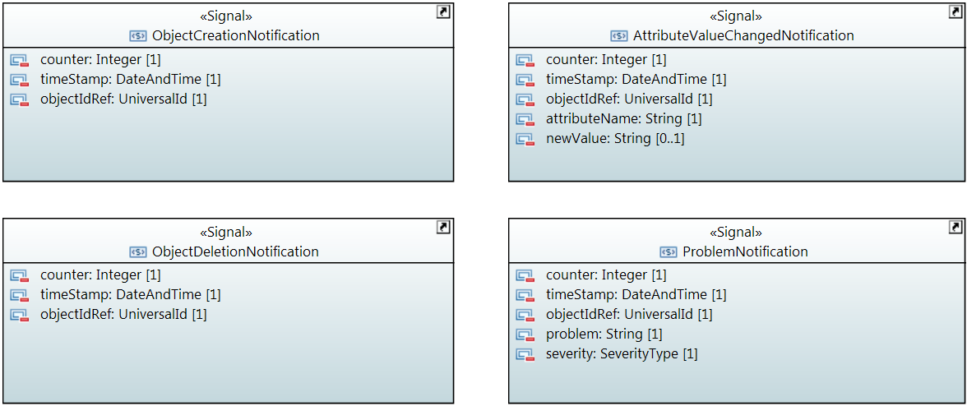

## AttributeValueChangedNotification

Qualified Name: MicrowaveModel::Notifications::AttributeValueChangedNotification

To be sent when an attribute has changed and one or more controllers have to update their data.

Applied stereotypes:

* OpenModelNotification
* triggerConditionList: invalid
* support: MANDATORY

Table 75: Attributes for AttributeValueChangedNotification

| **Attribute Name** | **Type DefaultValue** | **Multiplicity** | **Access** | **Stereotypes** | **Description** |
| --- | --- | --- | --- | --- | --- |
| counter | Integer  -1 | 1 | RW | OpenModelAttribute   * partOfObjectKey: 0 * AVC: NO * isInvariant: true * valueRange: no range constraint * bitLength: LENGTH_32_BIT * unit: no unit defined * support: MANDATORY | Counts attribute value changed notifications. |
| timeStamp | DateAndTime  20101120140000.0Z+1 | 1 | RW | OpenModelAttribute   * partOfObjectKey: 0 * AVC: NO * isInvariant: true * valueRange: no range constraint * bitLength: NA * unit: no unit defined * support: MANDATORY |  |
| objectIdRef | UniversalId  ./. | 1 | RW | OpenModelAttribute   * partOfObjectKey: 0 * AVC: NO * isInvariant: true * valueRange: no range constraint * bitLength: NA * unit: no unit defined * support: MANDATORY | ID of the affected MW_AirInterface_Pac, MW_AirInterfaceDiversity_Pac, MW_Structure_Pac, MW_PureEthernetStructure_Pac, MW_HybridMwStructure_Pac, MW_Container_Pac, MW_EthernetContainer_Pac or MW_TdmContainer_Pac. |
| attributeName | String  Attribute name not specified. | 1 | RW | OpenModelAttribute   * partOfObjectKey: 0 * AVC: NO * isInvariant: true * valueRange: no range constraint * bitLength: NA * unit: no unit defined * support: MANDATORY | Name of the attribute that has been changed. |
| newValue | String  New value not specified. | 0..1 | RW | OpenModelAttribute   * partOfObjectKey: 0 * AVC: NO * isInvariant: true * valueRange: no range constraint * bitLength: NA * unit: no unit defined * support: MANDATORY | Attribute value converted to a string (xml, json, ...) |

## ObjectCreationNotification

Qualified Name: MicrowaveModel::Notifications::ObjectCreationNotification

To be sent when a new MW_AirInterface_Pac, MW_AirInterfaceDiversity_Pac, MW_Structure_Pac, MW_PureEthernetStructure_Pac, MW_HybridMwStructure_Pac, MW_Container_Pac, MW_EthernetContainer_Pac or MW_TdmContainer_Pac has to be instancieted in the controller.

Applied stereotypes:

* OpenModelNotification
* triggerConditionList: invalid
* support: MANDATORY

Table 76: Attributes for ObjectCreationNotification

| **Attribute Name** | **Type DefaultValue** | **Multiplicity** | **Access** | **Stereotypes** | **Description** |
| --- | --- | --- | --- | --- | --- |
| counter | Integer  -1 | 1 | RW | OpenModelAttribute   * partOfObjectKey: 0 * AVC: NO * isInvariant: true * valueRange: no range constraint * bitLength: LENGTH_32_BIT * unit: no unit defined * support: MANDATORY | Counts object creation notifications. |
| timeStamp | DateAndTime  20101120140000.0Z+1 | 1 | RW | OpenModelAttribute   * partOfObjectKey: 0 * AVC: NO * isInvariant: true * valueRange: no range constraint * bitLength: NA * unit: no unit defined * support: MANDATORY |  |
| objectIdRef | UniversalId  ./. | 1 | RW | OpenModelAttribute   * partOfObjectKey: 0 * AVC: NO * isInvariant: true * valueRange: no range constraint * bitLength: NA * unit: no unit defined * support: MANDATORY | ID of the affected MW_AirInterface_Pac, MW_AirInterfaceDiversity_Pac, MW_Structure_Pac, MW_PureEthernetStructure_Pac, MW_HybridMwStructure_Pac, MW_Container_Pac, MW_EthernetContainer_Pac or MW_TdmContainer_Pac. |
| objectType | String  Type of created object not specified. | 1 | RW | OpenModelAttribute   * partOfObjectKey: 0 * AVC: NO * isInvariant: true * valueRange: no range constraint * bitLength: NA * unit: no unit defined * support: MANDATORY | Type of Object to be chosen from the following list of values: 'MW_AirInterface_Pac', 'MW_AirInterfaceDiversity_Pac', 'MW_Structure_Pac', 'MW_PureEthernetStructure_Pac', 'MW_HybridMwStructure_Pac', 'MW_Container_Pac', 'MW_EthernetContainer_Pac' or 'MW_TdmContainer_Pac'. |

## ObjectDeletionNotification

Qualified Name: MicrowaveModel::Notifications::ObjectDeletionNotification

To be sent when a new MW_AirInterface_Pac, MW_AirInterfaceDiversity_Pac, MW_Structure_Pac, MW_PureEthernetStructure_Pac, MW_HybridMwStructure_Pac, MW_Container_Pac, MW_EthernetContainer_Pac or MW_TdmContainer_Pac instance has to be deleted in the controller.

Applied stereotypes:

* OpenModelNotification
* triggerConditionList: invalid
* support: MANDATORY

Table 77: Attributes for ObjectDeletionNotification

| **Attribute Name** | **Type DefaultValue** | **Multiplicity** | **Access** | **Stereotypes** | **Description** |
| --- | --- | --- | --- | --- | --- |
| counter | Integer  -1 | 1 | RW | OpenModelAttribute   * partOfObjectKey: 0 * AVC: NO * isInvariant: true * valueRange: no range constraint * bitLength: LENGTH_32_BIT * unit: no unit defined * support: MANDATORY | Counts object deletion notifications. |
| timeStamp | DateAndTime  20101120140000.0Z+1 | 1 | RW | OpenModelAttribute   * partOfObjectKey: 0 * AVC: NO * isInvariant: true * valueRange: no range constraint * bitLength: NA * unit: no unit defined * support: MANDATORY |  |
| objectIdRef | UniversalId  ./. | 1 | RW | OpenModelAttribute   * partOfObjectKey: 0 * AVC: NO * isInvariant: true * valueRange: no range constraint * bitLength: NA * unit: no unit defined * support: MANDATORY | ID of the affected MW_AirInterface_Pac, MW_AirInterfaceDiversity_Pac, MW_Structure_Pac, MW_PureEthernetStructure_Pac, MW_HybridMwStructure_Pac, MW_Container_Pac, MW_EthernetContainer_Pac or MW_TdmContainer_Pac. |

## ProblemNotification

Qualified Name: MicrowaveModel::Notifications::ProblemNotification

To be sent when a problem occurs at a MW_AirInterface_Pac, MW_AirInterfaceDiversity_Pac, MW_Structure_Pac, MW_PureEthernetStructure_Pac, MW_HybridMwStructure_Pac, MW_Container_Pac, MW_EthernetContainer_Pac or MW_TdmContainer_Pac.

Applied stereotypes:

* OpenModelNotification
* triggerConditionList: invalid
* support: MANDATORY

Table 78: Attributes for ProblemNotification

| **Attribute Name** | **Type DefaultValue** | **Multiplicity** | **Access** | **Stereotypes** | **Description** |
| --- | --- | --- | --- | --- | --- |
| counter | Integer  -1 | 1 | RW | OpenModelAttribute   * partOfObjectKey: 0 * AVC: NO * isInvariant: true * valueRange: no range constraint * bitLength: LENGTH_32_BIT * unit: no unit defined * support: MANDATORY | Counts problem notifications |
| timeStamp | DateAndTime  20101120140000.0Z+1 | 1 | RW | OpenModelAttribute   * partOfObjectKey: 0 * AVC: NO * isInvariant: true * valueRange: no range constraint * bitLength: NA * unit: no unit defined * support: MANDATORY |  |
| objectIdRef | UniversalId  ./. | 1 | RW | OpenModelAttribute   * partOfObjectKey: 0 * AVC: NO * isInvariant: true * valueRange: no range constraint * bitLength: NA * unit: no unit defined * support: MANDATORY | ID of the affected MW_AirInterface_Pac, MW_AirInterfaceDiversity_Pac, MW_Structure_Pac, MW_PureEthernetStructure_Pac, MW_HybridMwStructure_Pac, MW_Container_Pac, MW_EthernetContainer_Pac or MW_TdmContainer_Pac. |
| problem | String  Problem name not specified. | 1 | RW | OpenModelAttribute   * partOfObjectKey: 0 * AVC: NO * isInvariant: true * valueRange: no range constraint * bitLength: NA * unit: no unit defined * support: MANDATORY | Name of the problem according to AirInterface::AirInterfaceCapability::supportedAlarms or AirInterfaceDiversity::AirInterfaceDiversityCapability::supportedAlarms or Structure::StructureCapability::supportedAlarms or PureEthernetStructure::PureEthernetStructureCapability::supportedAlarms or HybridMwStructure::HybridMwStructureCapability::supportedAlarms or Container::ContainerCapability::supportedAlarms or EthernetContainer::EthernetContainerCapability::supportedAlarms or TdmContainer::TdmContainerCapability::supportedAlarms. |
| severity | SeverityType  WARNING | 1 | RW | OpenModelAttribute   * partOfObjectKey: 0 * AVC: NO * isInvariant: true * valueRange: no range constraint * bitLength: NA * unit: no unit defined * support: MANDATORY | Severity of the problem according to AirInterface::AirInterfaceConfiguration::problemSeverityList, AirInterfaceDiversity::AirInterfaceDiversityConfiguration::problemSeverityList, Structure::StructureConfiguration::problemSeverityList, PureEthernetStructure::PureEthernetStructureConfiguration::problemSeverityList, HybridMwStructure::HybridMwStructureConfiguration::problemSeverityList, Container::ContainerConfiguration::problemSeverityList, EthernetContainer::EthernetContainerConfiguration::problemSeverityList or TdmContainer::TdmContainerConfiguration::problemSeverityList |